4501ICBTME

PRINCIPLES OF ELECTRICAL AND ELECTRONIC ENGINEERING

Instructed by : Mr. Ruwan Fernando/ Thilina Chamalka Jayasinghe

**Name :** Mohomad Irshad MashoodPackeer

**Student No :** CL/HDMCL/12/09

**Batch :** 12

**Assignment Title :** Principles of Electrical and Electronics Engineering

**Date Sub :** 29/12/2019

# Title

4501ICBTME - Principles of electrical and electronic engineering

# **Task 01**

## Objective

The objective of this practical will be to find how the voltage divide when the resistors are connected in series, in parallel and both series and parallel.

## Equipment

Multi-meter, DC power supply, resistors with two 1kΩ and one 10kΩ, breadboard, jumper wires.

## Methodology

### When the connection is in series

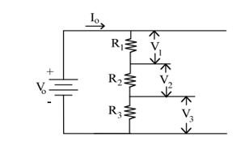

Figure 1 Diagram of the resistors connected in series

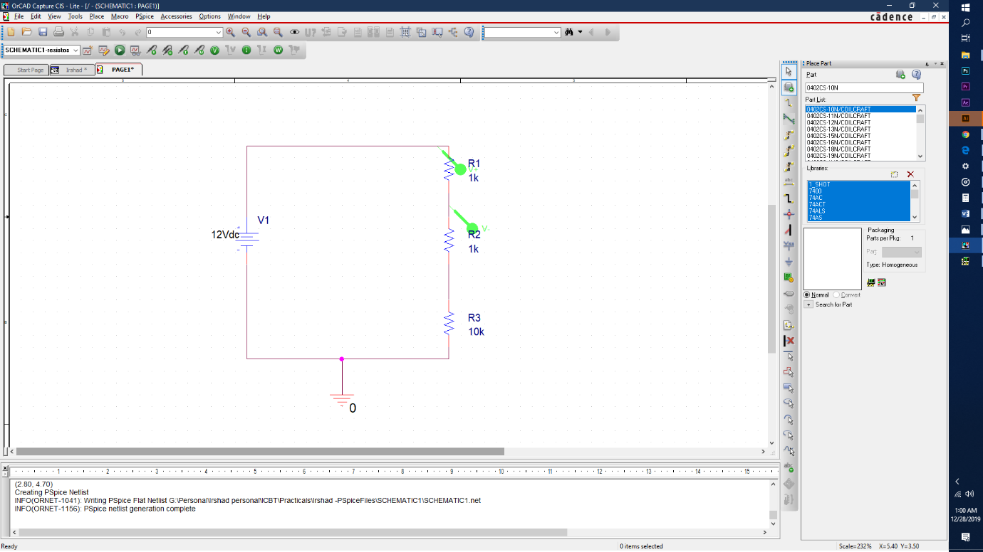

Figure 2 Orcad design of resistor in series

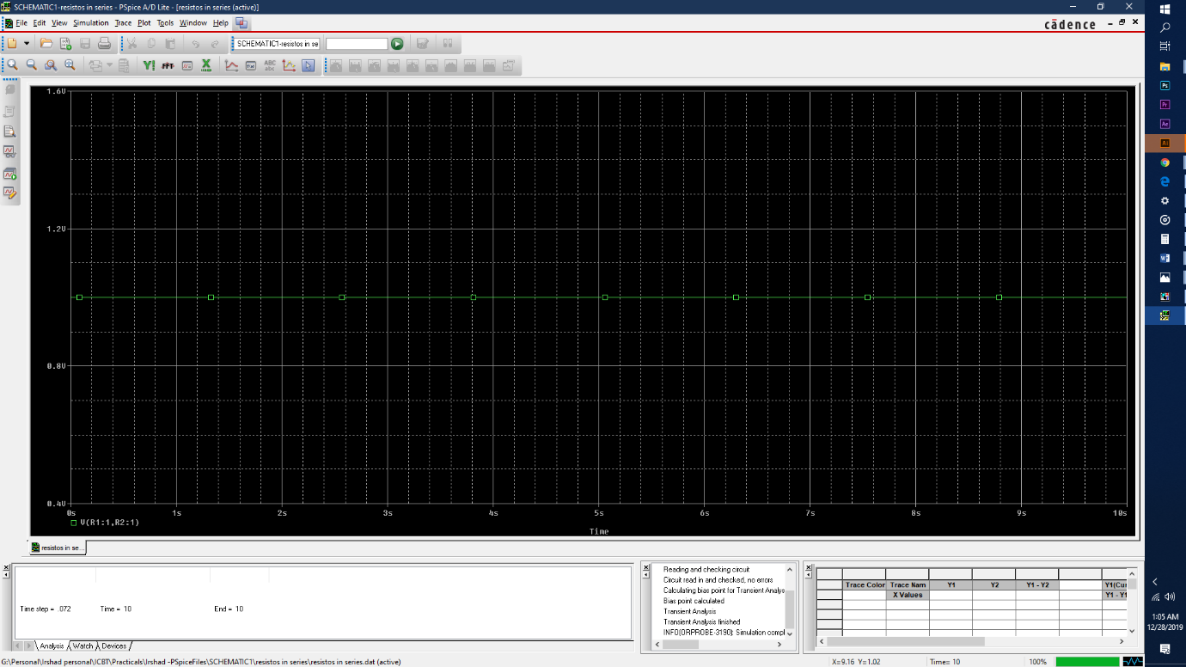

Figure 3 Output wave form of V1 in 1K Ohm resistor

Figure 4 Output wave form of V1 in 1K Ohm resistor

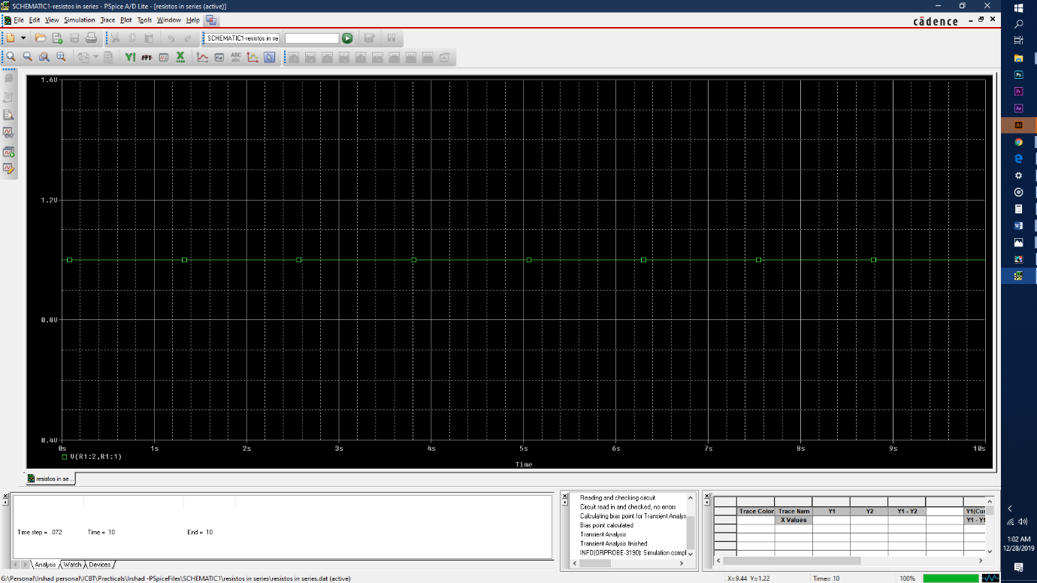

#### Constructing the circuit in the laboratory

Figure 5 Output wave form of V3 in 10K Ohm resistor

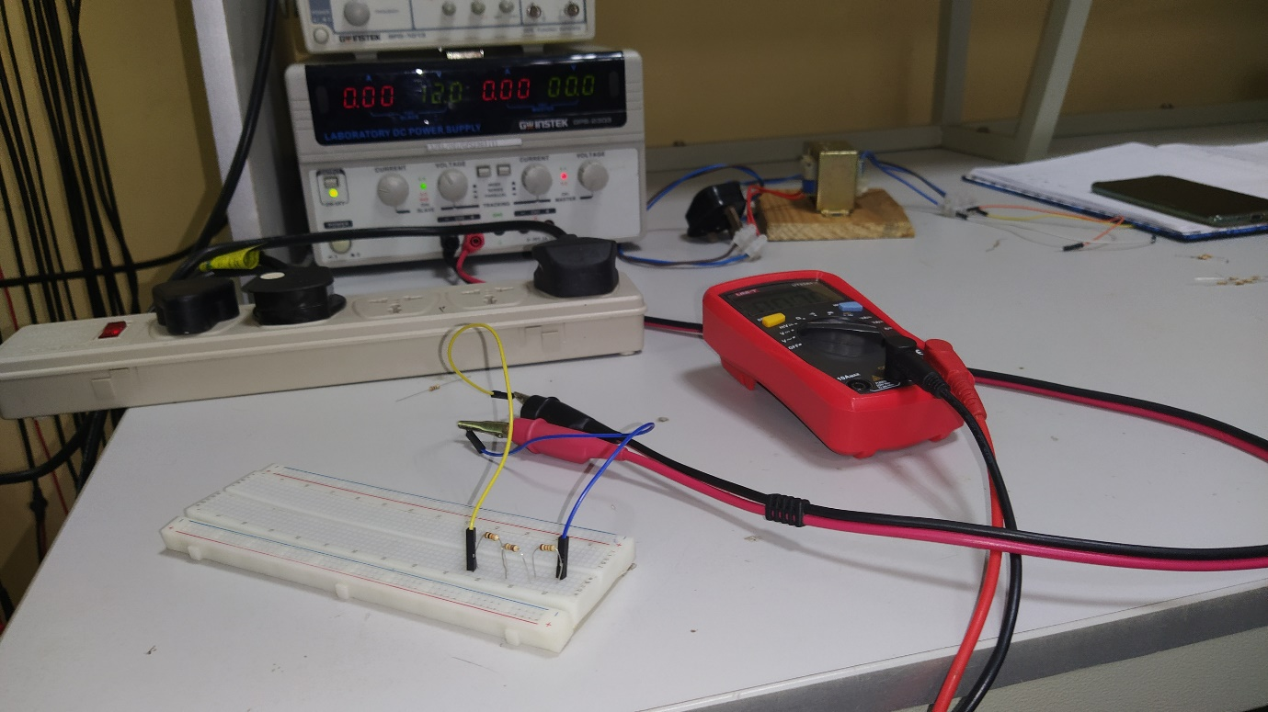To construct the circuit initially 3 resistors of 1k, 1k and 10k were connected in series in a breadboard where each end connects with the other except for the 1st and the last resistor end. Then by using jumper wires remaining both ends were connected to the DC power supply. By using a multimeter voltage difference through each resistor is calculated.

Figure 6 Resistor connected in series wide view

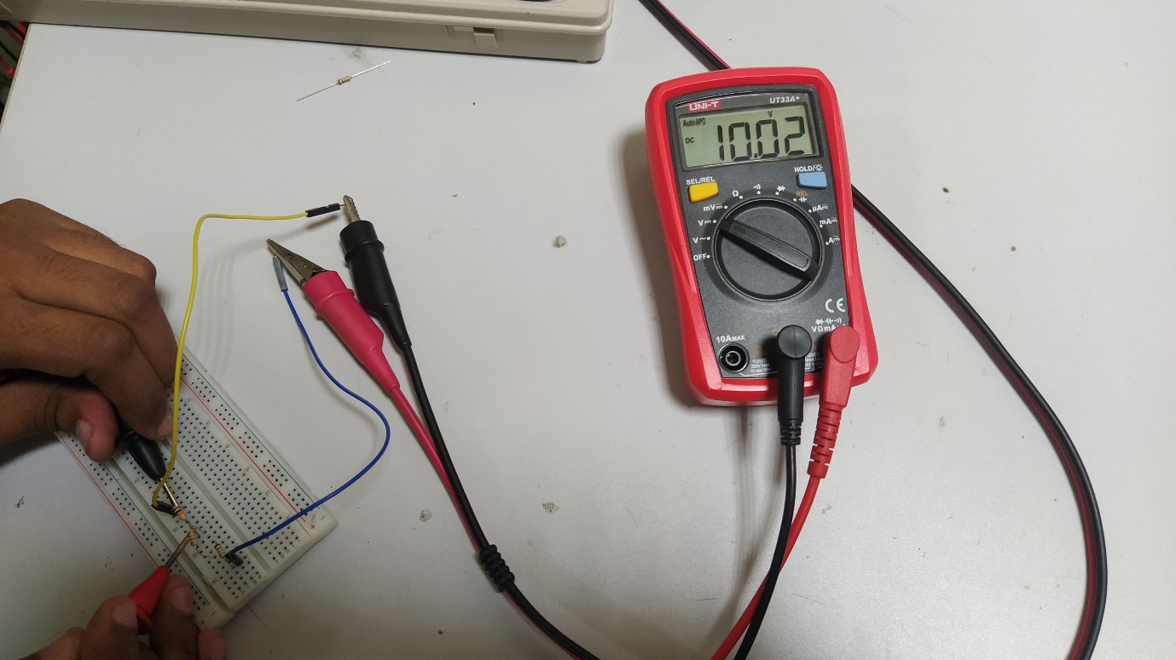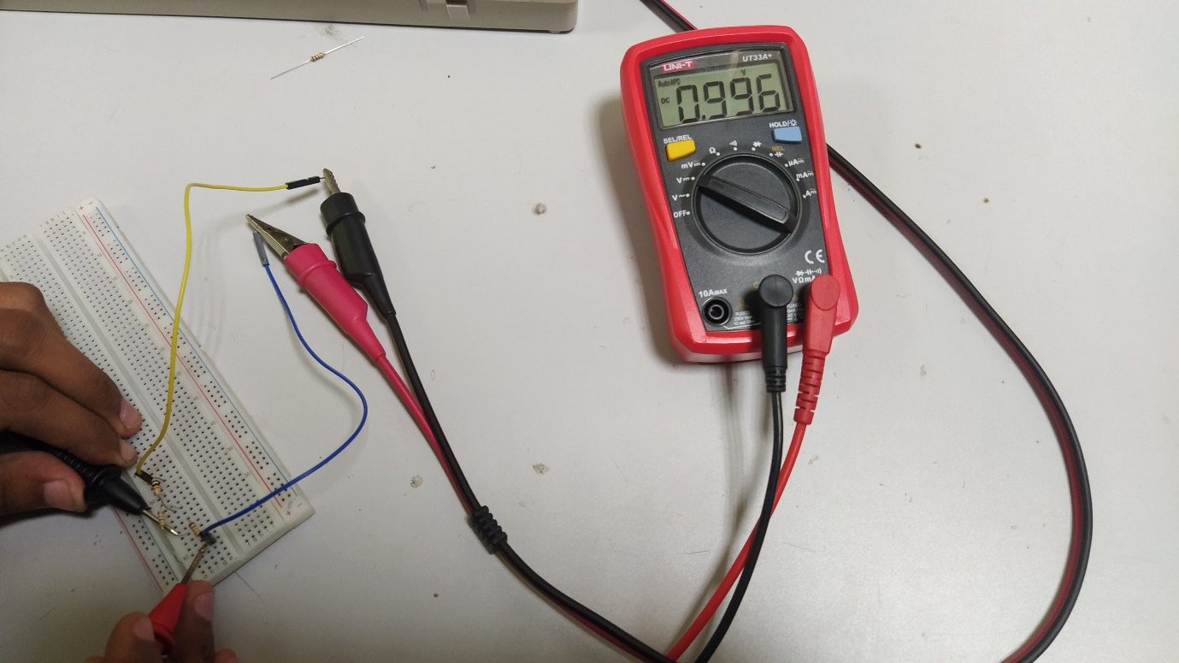

Figure 7 Calculation of the 1K ohm Resistor

Figure 8 Calculation of the 10k ohm resistor

|  |  |  |  |
| --- | --- | --- | --- |
| Circuit | V1 | V2 | V3 |
| In Series | 0.996 | 0.996 | 10.02 |

### When the connection is in parallel

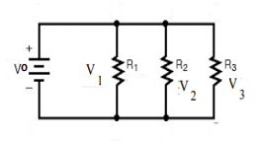

Figure 9 Diagram of resistors connected in parallel

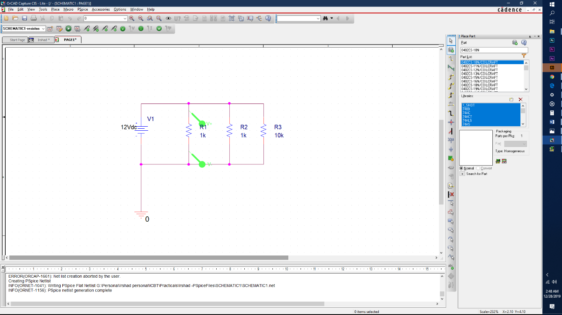

Figure 10 Orcad design of resistors in parallel

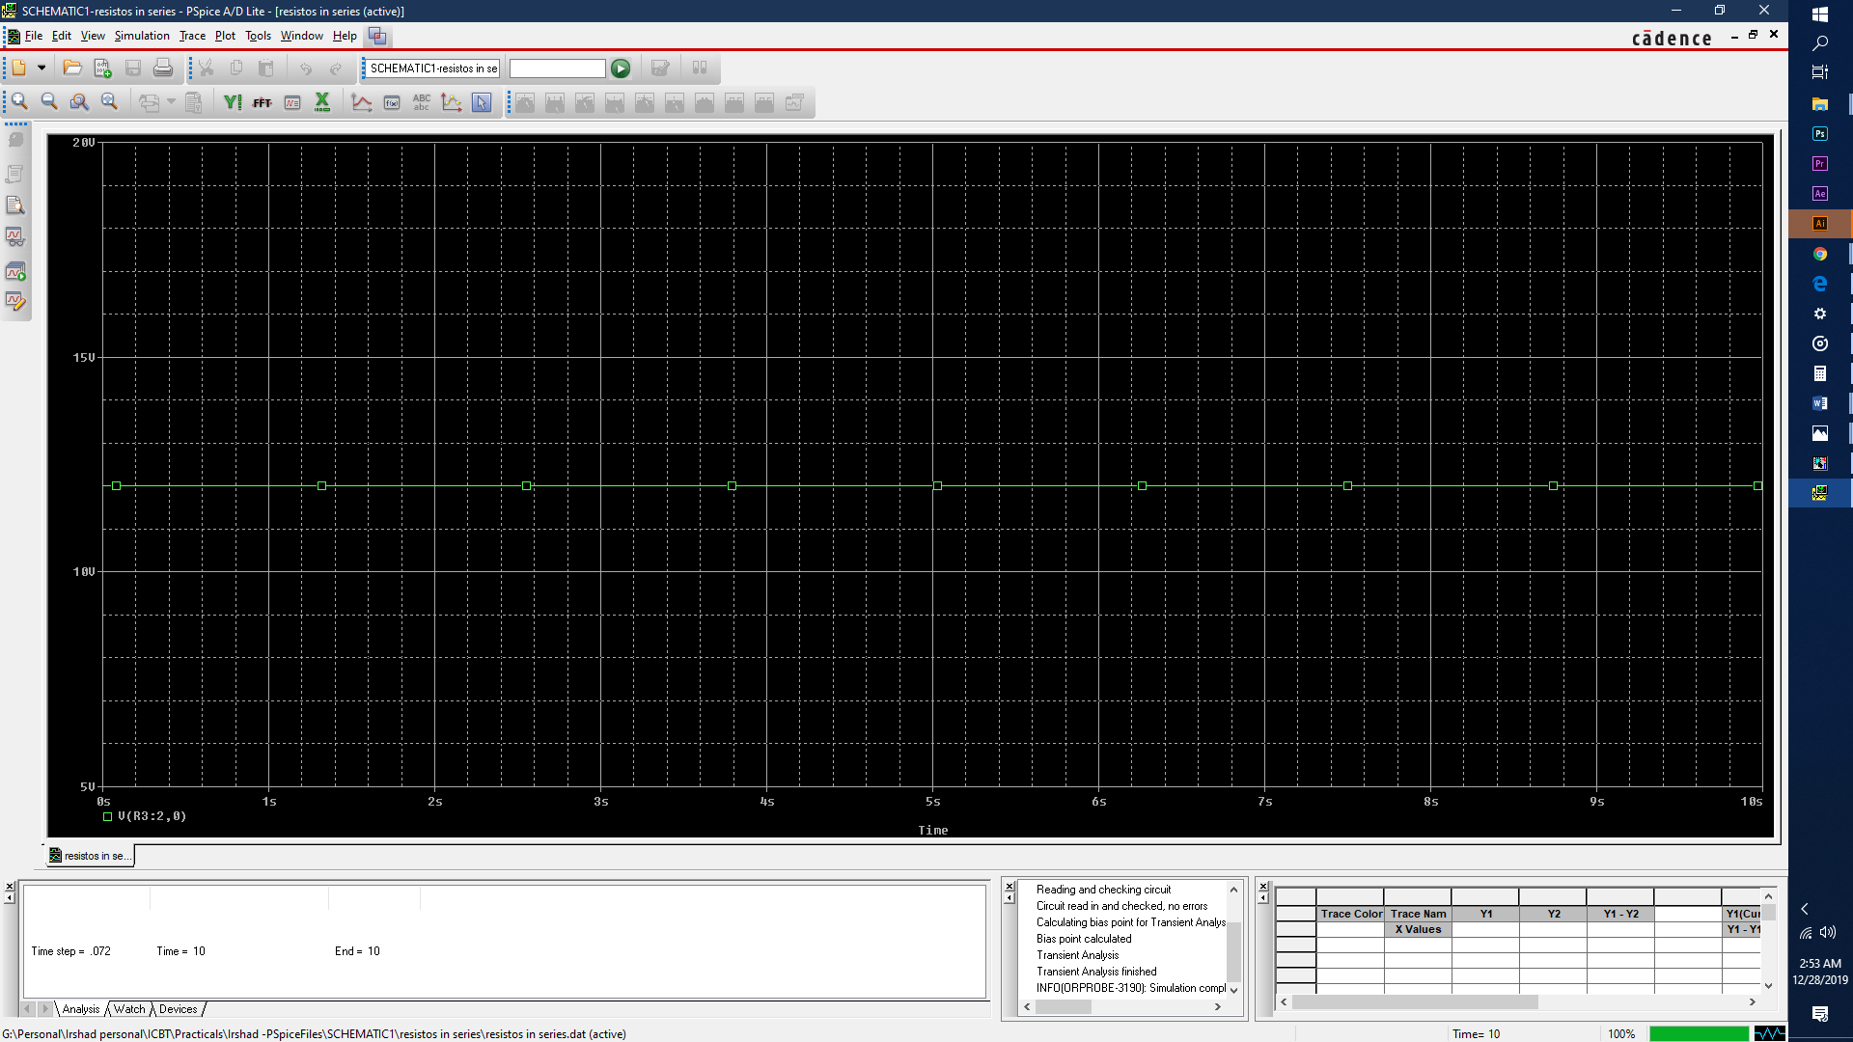

Figure 11 Output wave form of V1 in 1K ohm resistor

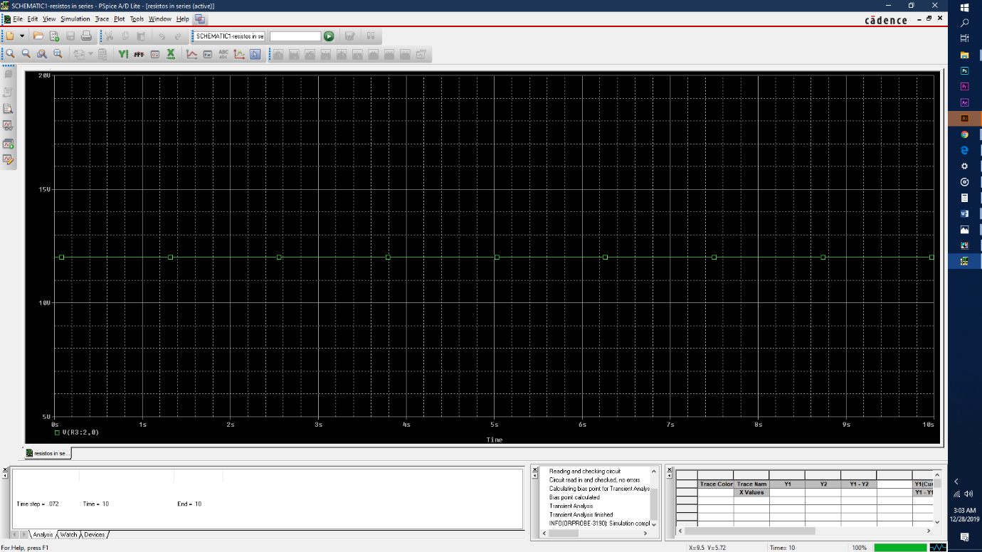

Figure 12 Output wave form of V2 in 1K ogm resistor

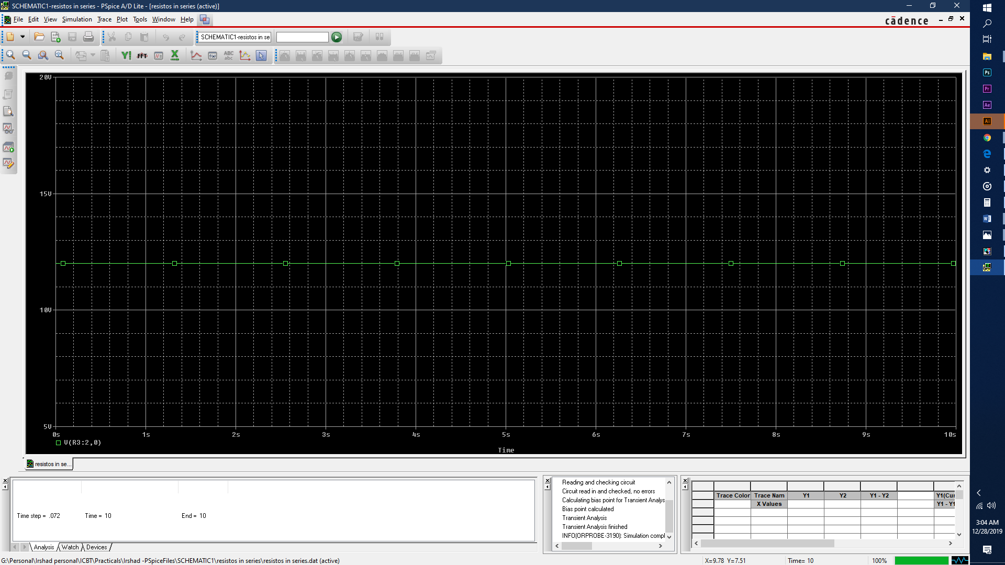

Figure 13Output wave form or V3 in 10K ohm resistor

#### Constructing the circuit in the laboratory

To build this circuit 3 resistors of 1k, 1k and 10k were connected in parallel in a breadboard. Then by using jumper wires circuit was connected to the DC power supply as shown in the figure 14 . By using a multimeter voltage difference through each resistor is calculated.

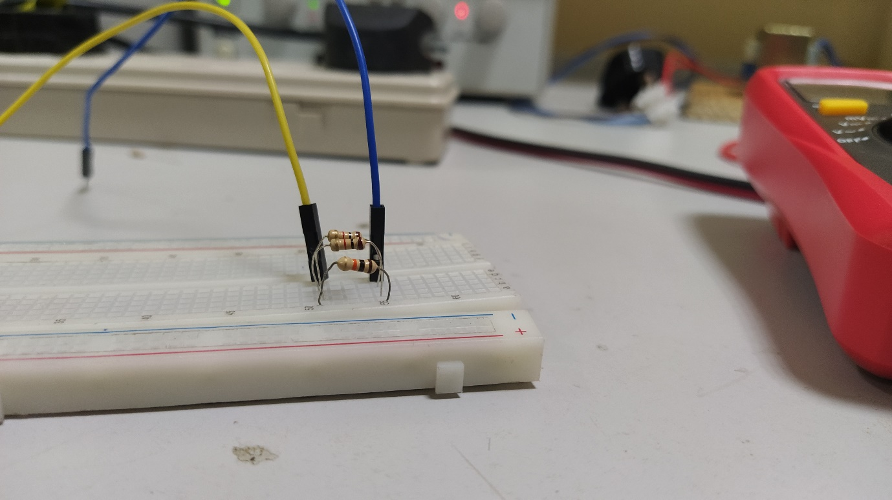

Figure 14 Resistors connected in Parallel

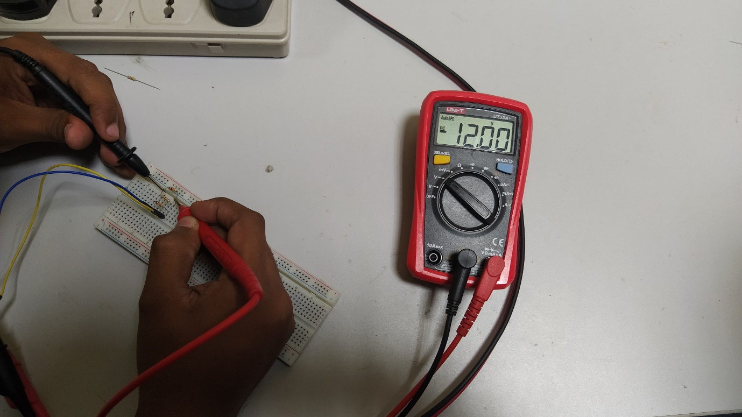

Figure 15 Calculation of V1 in 1k Ohm resistor

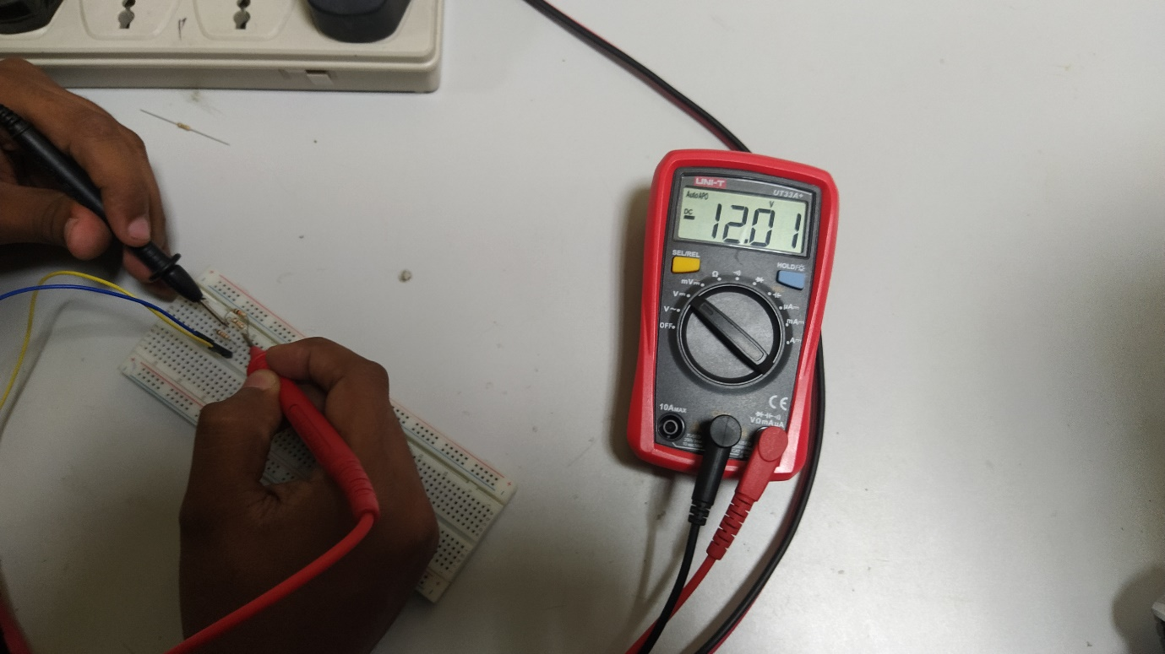

Figure 16 Calculation of V2 in 1K ohm resistor

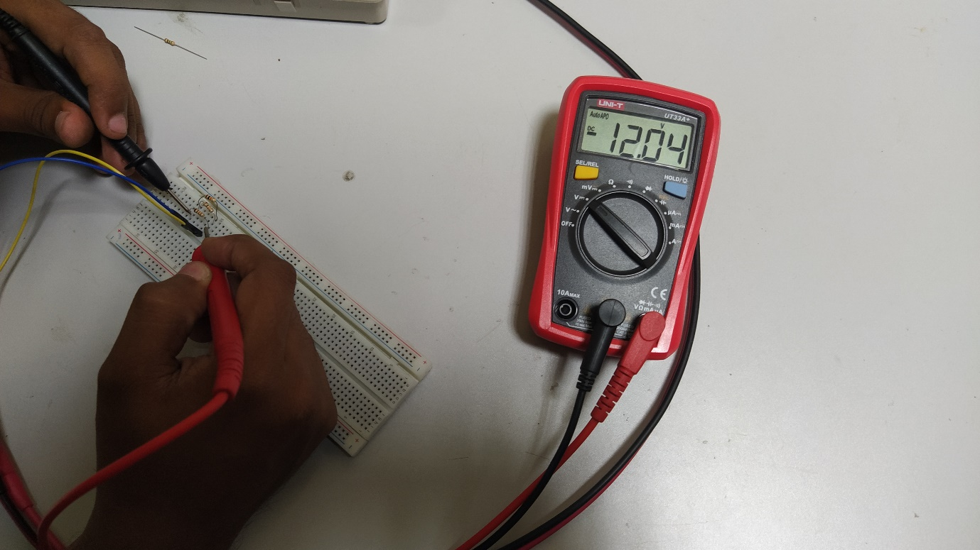

Figure 17 Calculation of V3 in 10K ohm resistor

|  |  |  |  |
| --- | --- | --- | --- |
| Circuit | V1 | V2 | V3 |
| In Parallel | 12.00 | 12.01 | 12.04 |

### When the connection is both parallel and series

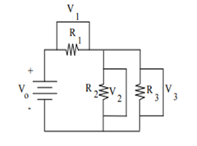

Figure 18 Diagram of resistors connected both series and parallel

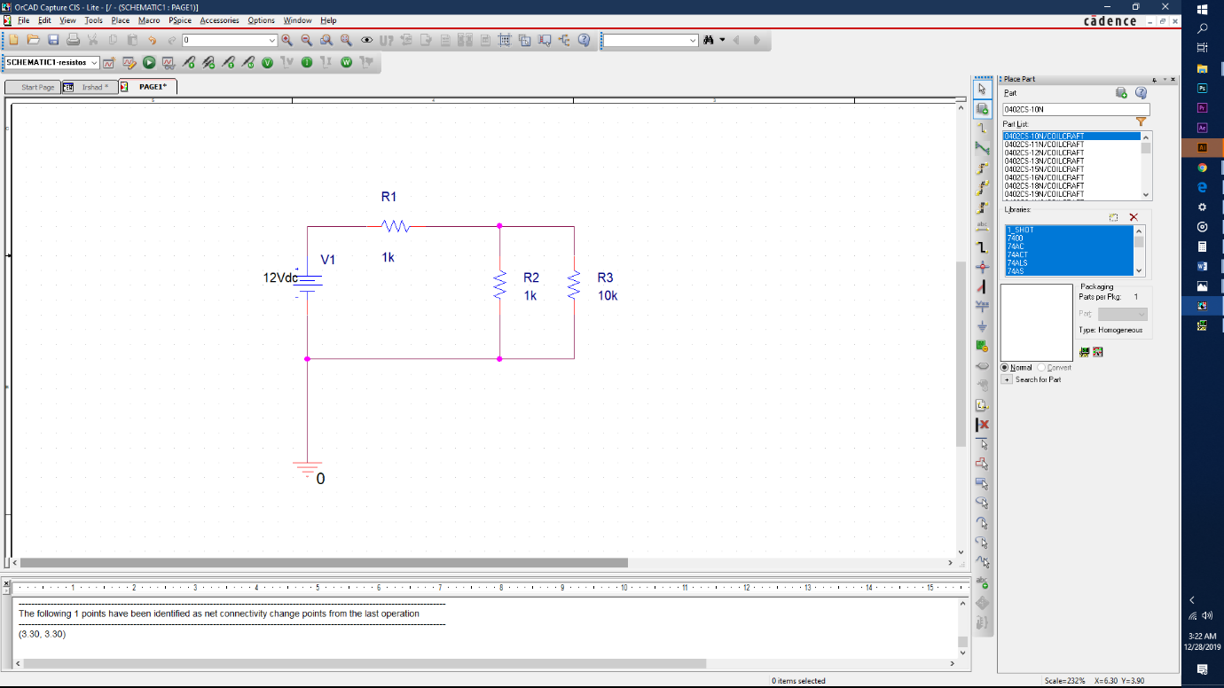

Figure 19 Orcad design of resistors connected both series and parallel

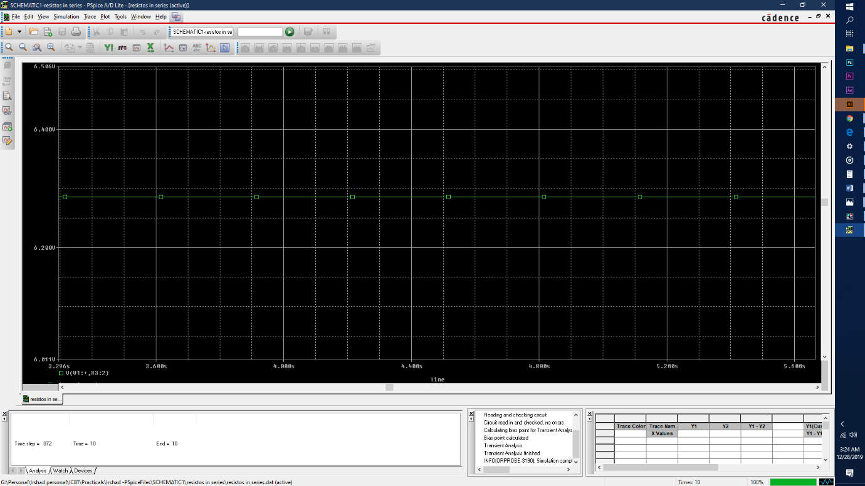

Figure 20 Output wave form of V1 in 1K Ohm resistor

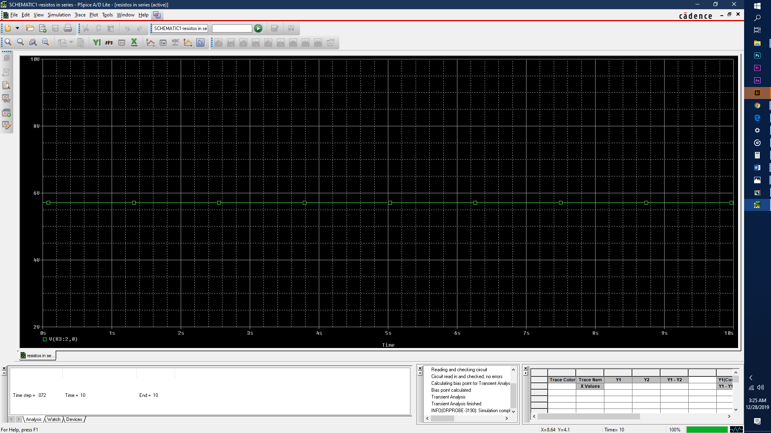

Figure 21 Output wave form of V2 in 1K ohm resistor

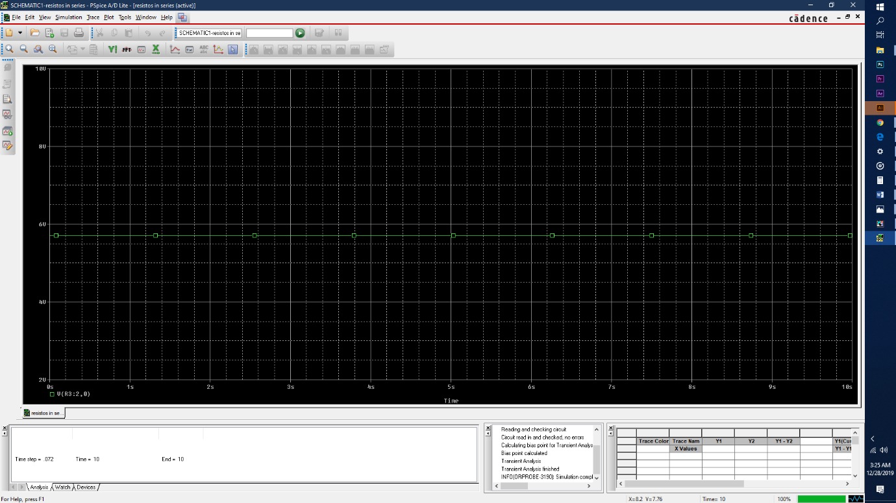

Figure 22 Output wave form of V3 in 10K ohm resistor

#### Constructing the circuit in the laboratory

In this circuit both series and parallel connection have been used. As shown in the figure 1k ohm is connected series to the circuit while another 1k ohm and 10k ohm resister is connected parallel.

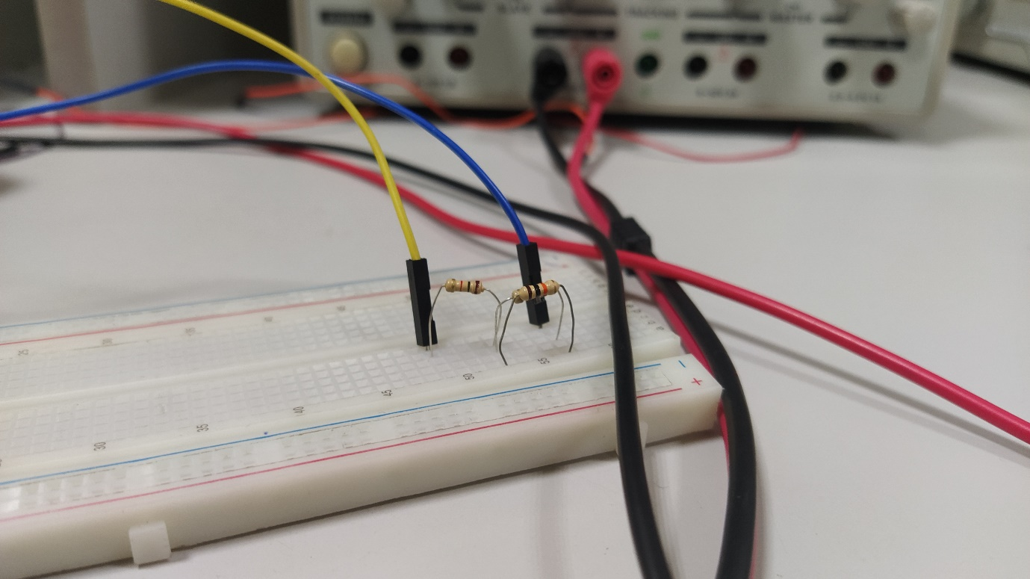

Figure 23 Resistors connected in both parallel and series

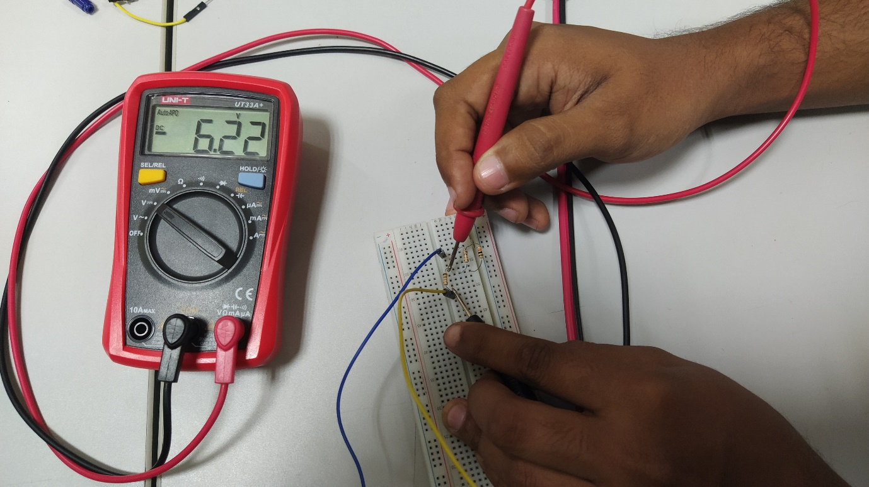

Figure 24 Calculation of V1 in 1k Ohm resistor

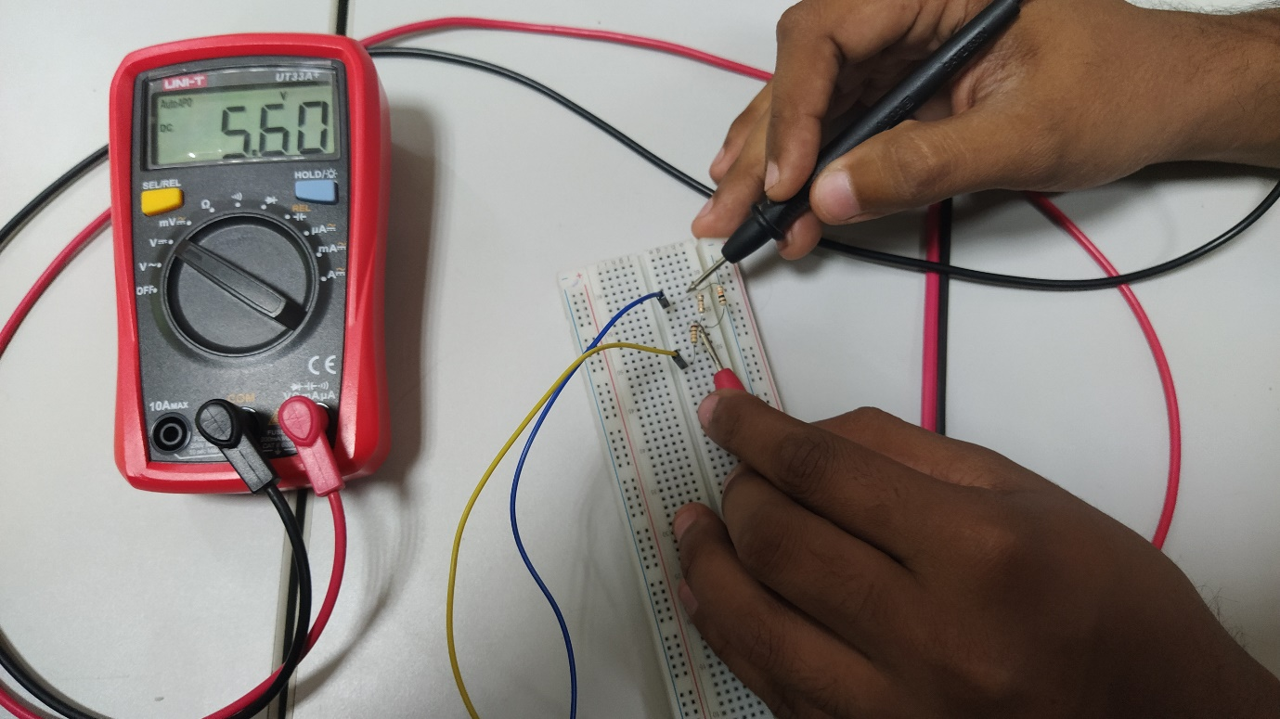

Figure 25 Calculation of V2 in 10K ohm resistor

|  |  |  |  |
| --- | --- | --- | --- |
| Circuit | V1 | V2 | V3 |
| Both in parallel and series | 6.22 | 5.60 | 5.60 |

# Task 3

## Objective

The objective of this task is to convert AC current into DC by rectification method.

## Equipment

5 silicon diodes, 1kΩ resistor, 22µF and 47µF capacitors, oscilloscope, Power supply, Multimeter, transformer, breadboard, jumper wires

### Methodology

#### Half wave rectifier

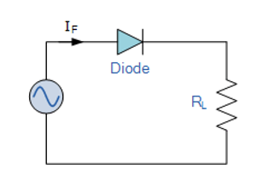

Figure 26 Diagram of half wave rectifier

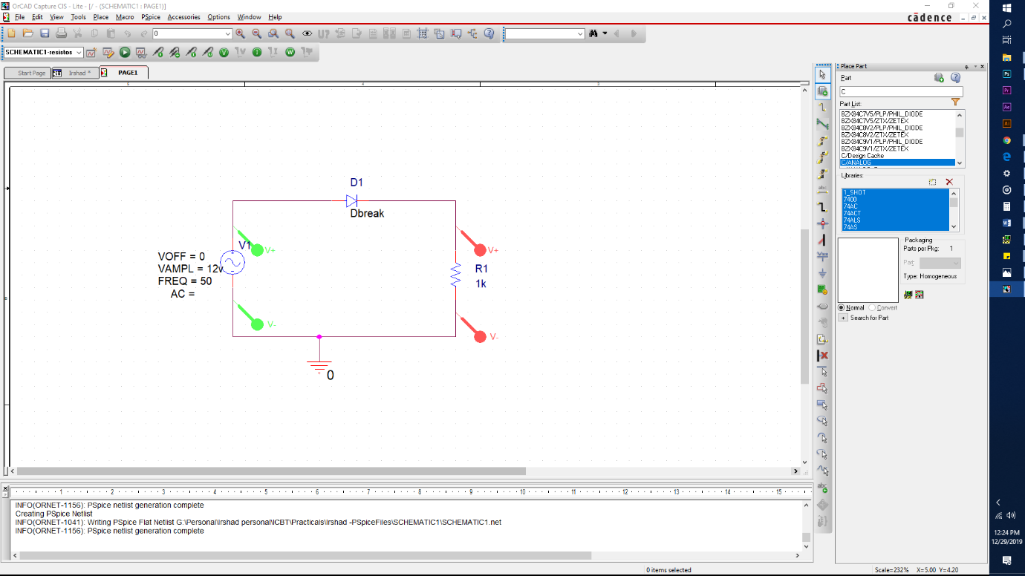

Figure 27 Orcad design of the half wave rectifiera

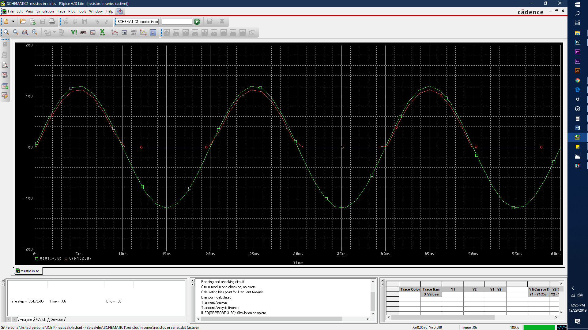

Figure 28 Output wave form of the Half wave rectifier

By looking at the output wave form it shows that the values of negative terminals have been removed by applying a diode into the circuit system.

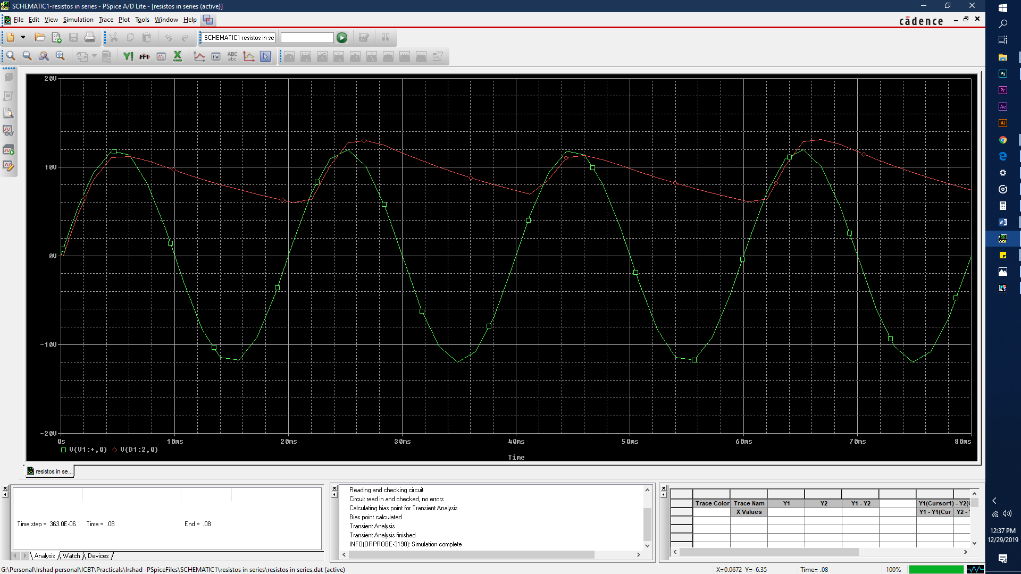

Figure 29 Output wave form after adding a 22µF capacitor

By adding a 22µF Capacitor in parallel to the load resistor in the circuit it shows that the wave doesn’t fall off to 0. The reason is the 22µF capacitor is providing a voltage to reduce the ripple voltage.

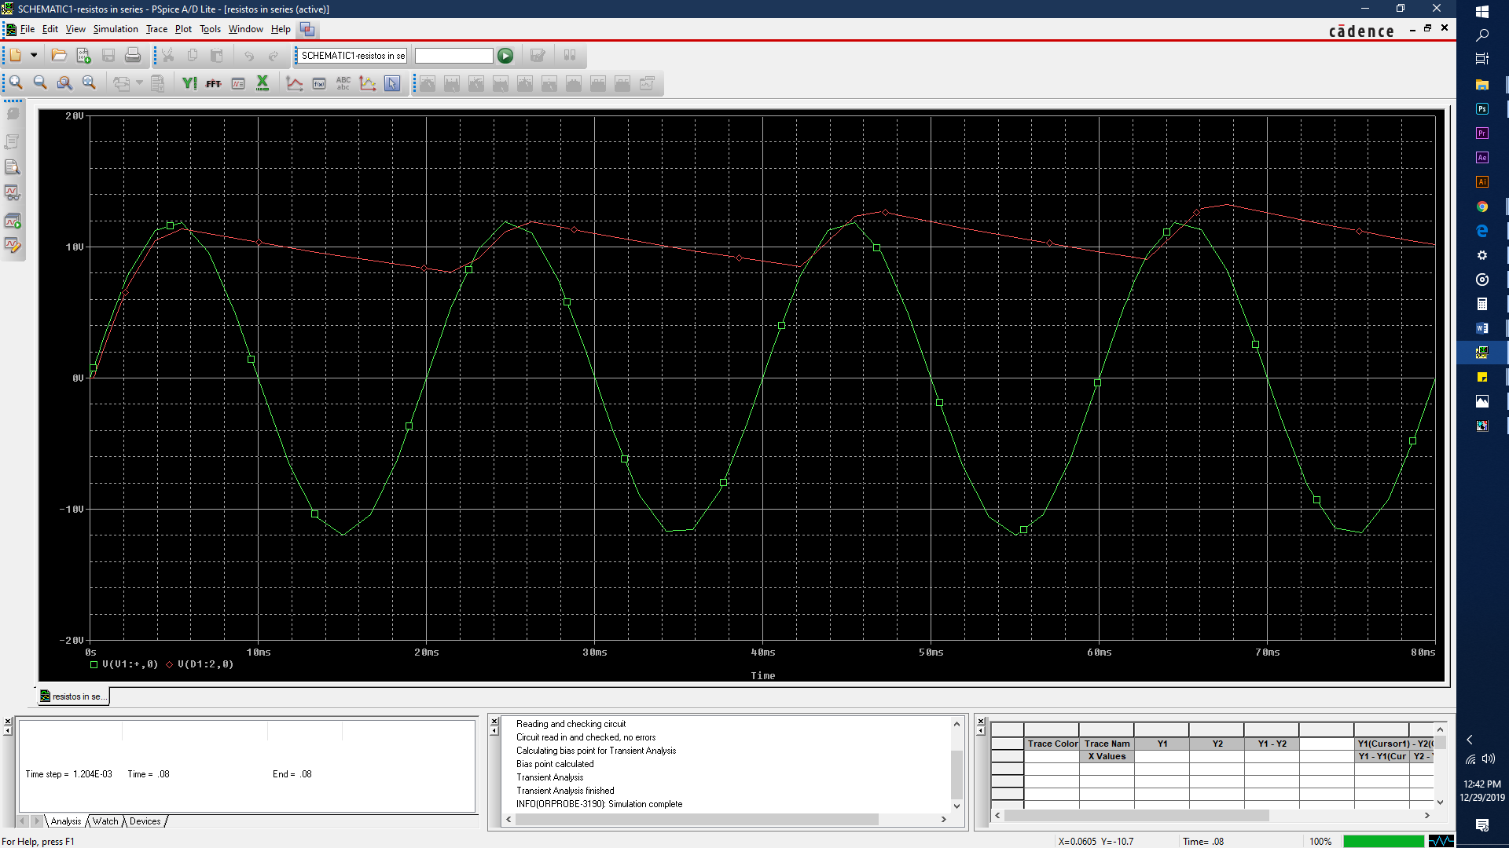

Figure 30 Output wave form after adding a 47µF capacitor

By adding a 47µF capacitor which is higher than the 22µF reduces more ripple voltage due to higher capacity of the conductor.

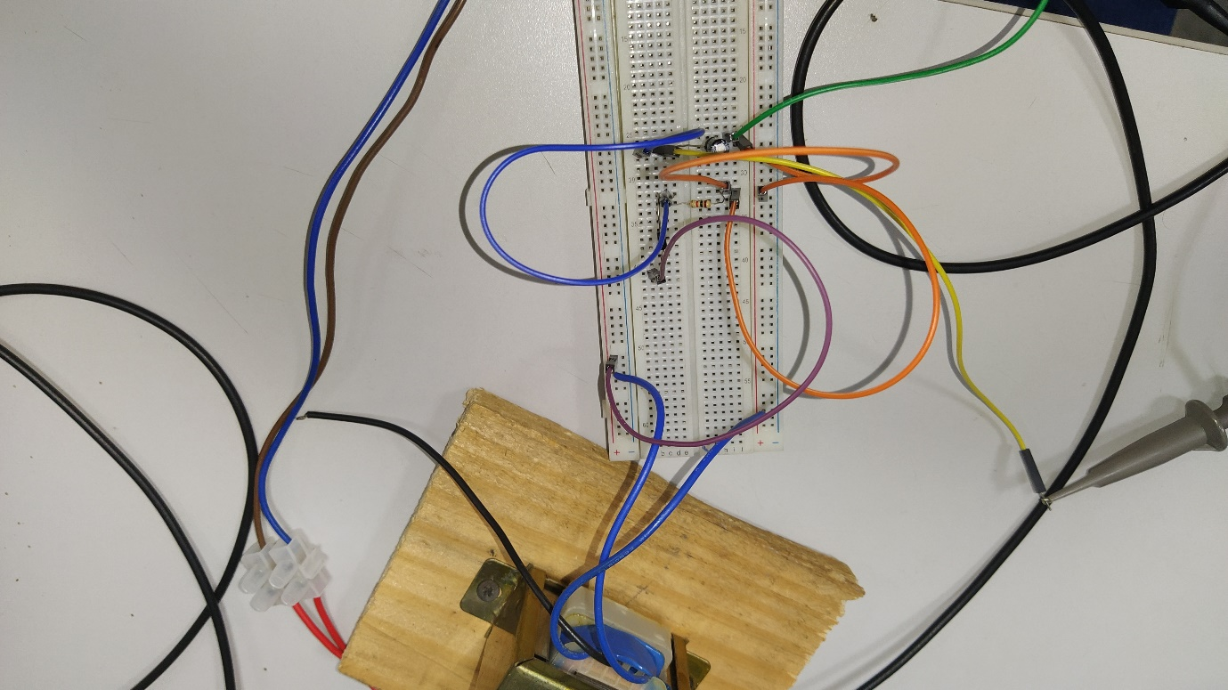

Figure 31 Circuit of the half wave rectifier

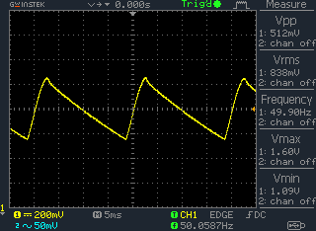

Figure 32 Output wave forms after half wave rectification

#### Full wave rectifier

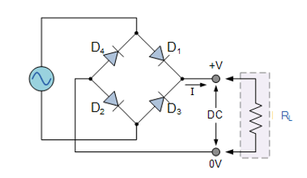

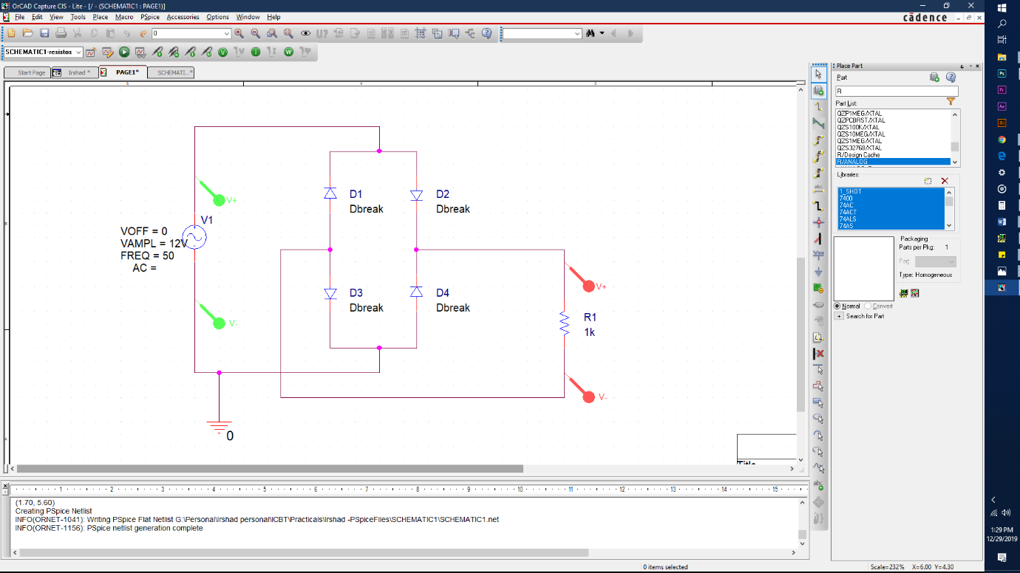

Figure 33 Orcad design of full wave rectifier

Figure 34 Diagram of full wave rectifier

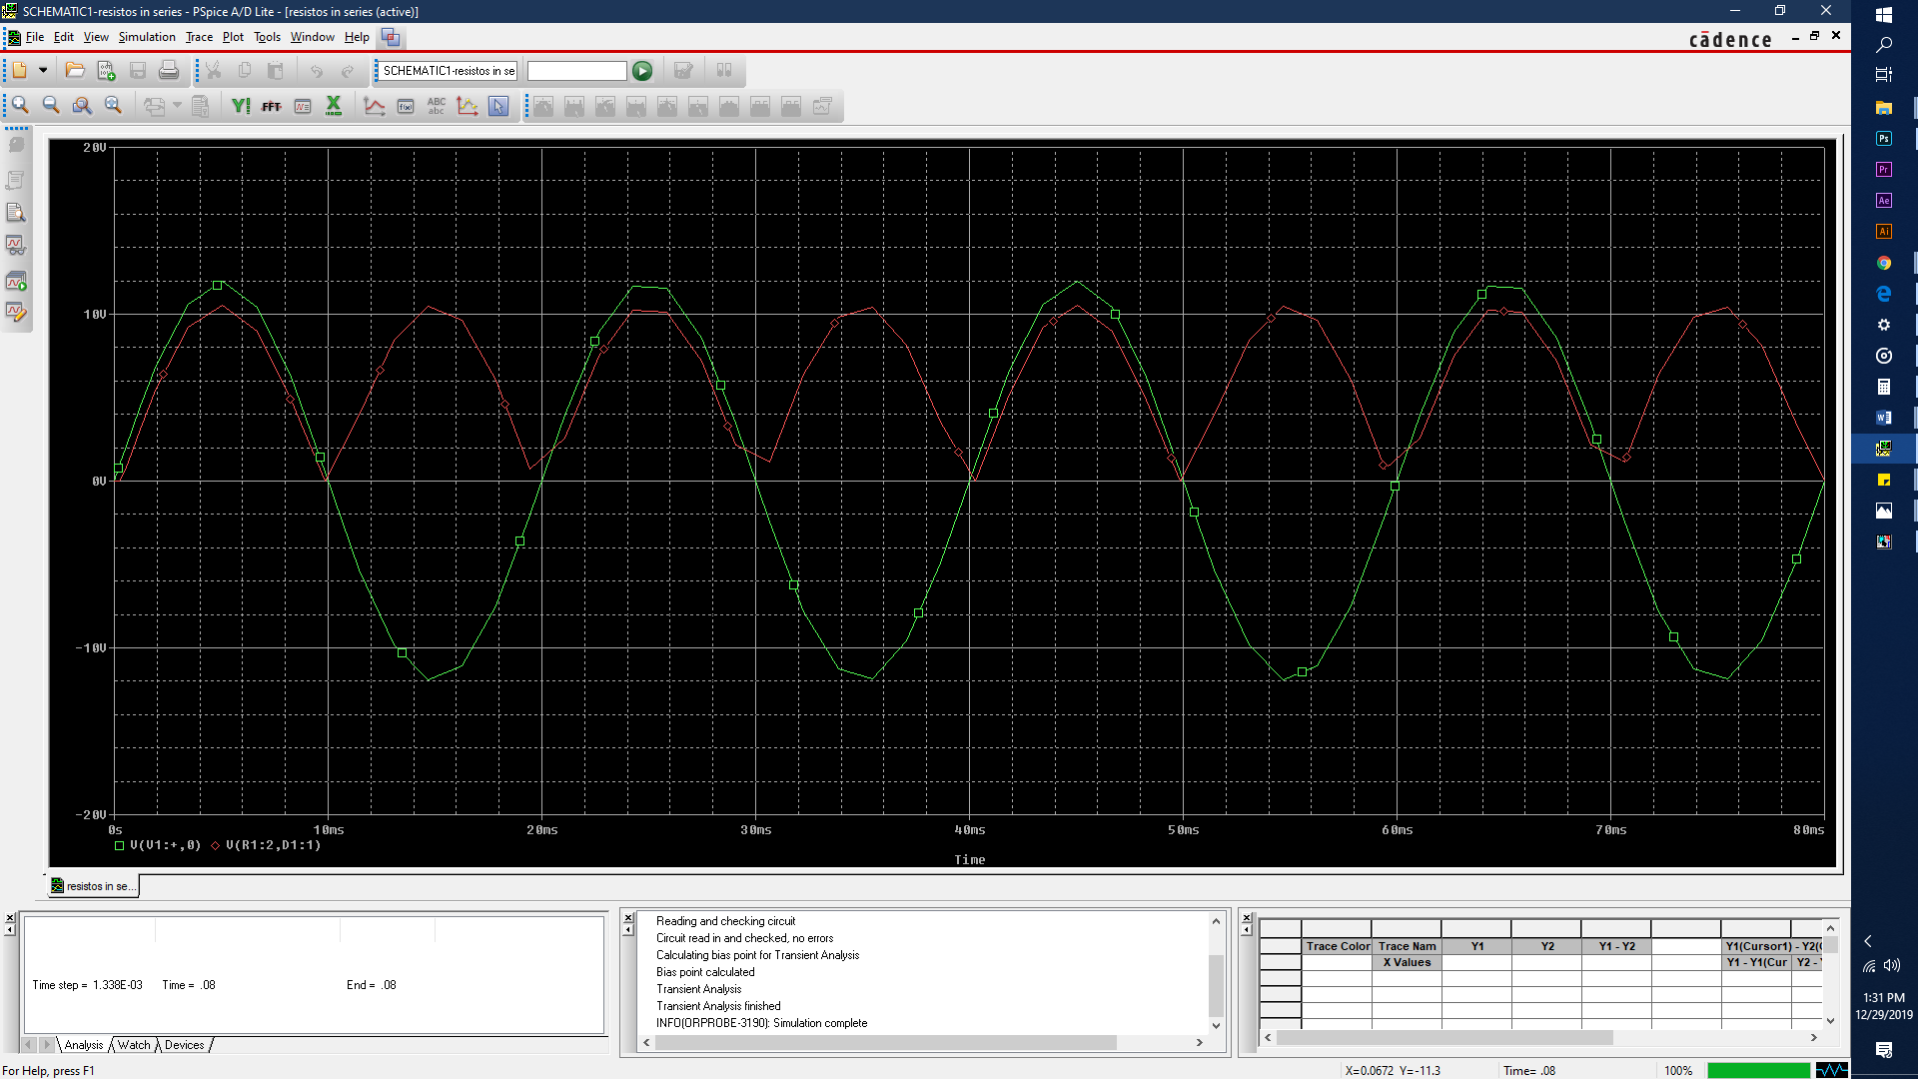In this circuit it shows that the negative wave also has been converted in to positive wave. The arrangement of the diodes in the circuit has taken place to keep the flowing of current in to the same direction.

Figure 35 Output wave form of full wave rectifier

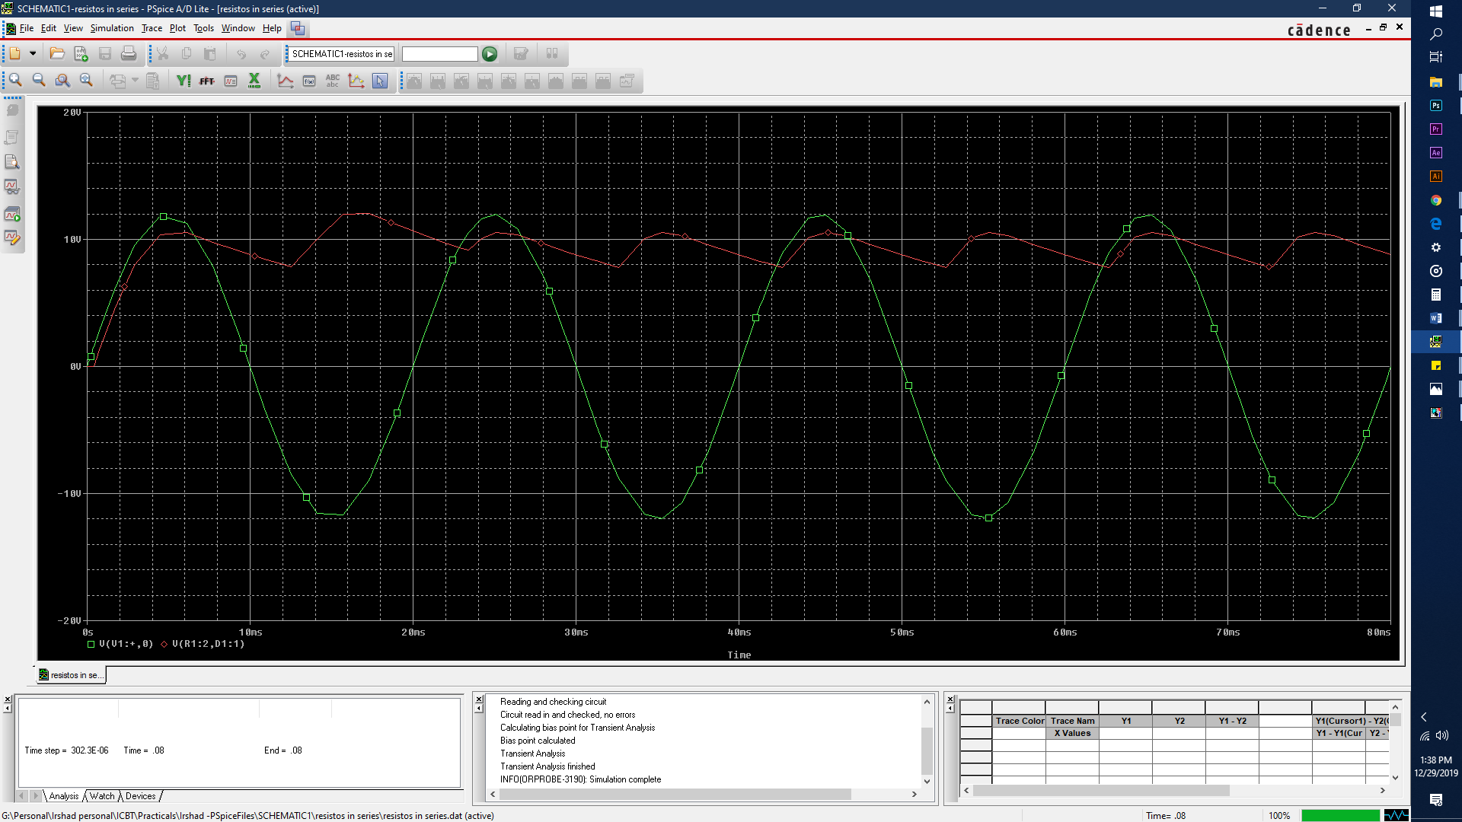

Figure 36 Output wave form with 22uF Capacitor

Adding a 22uF capacitor into the circuit has quietly reduced the ripple voltage.

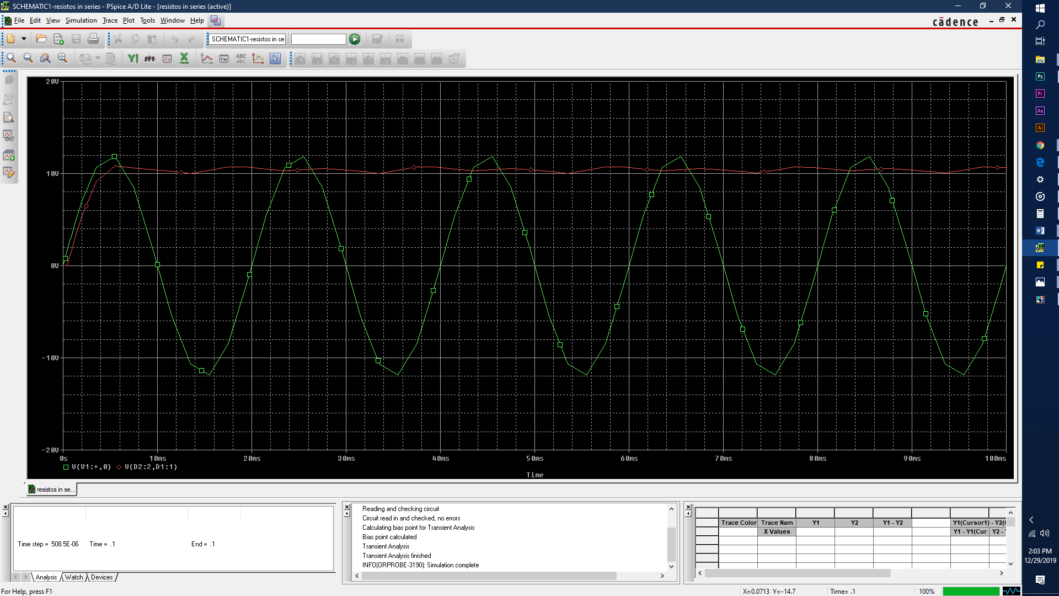

Figure 37 output wave form by adding a 47uF capacitor

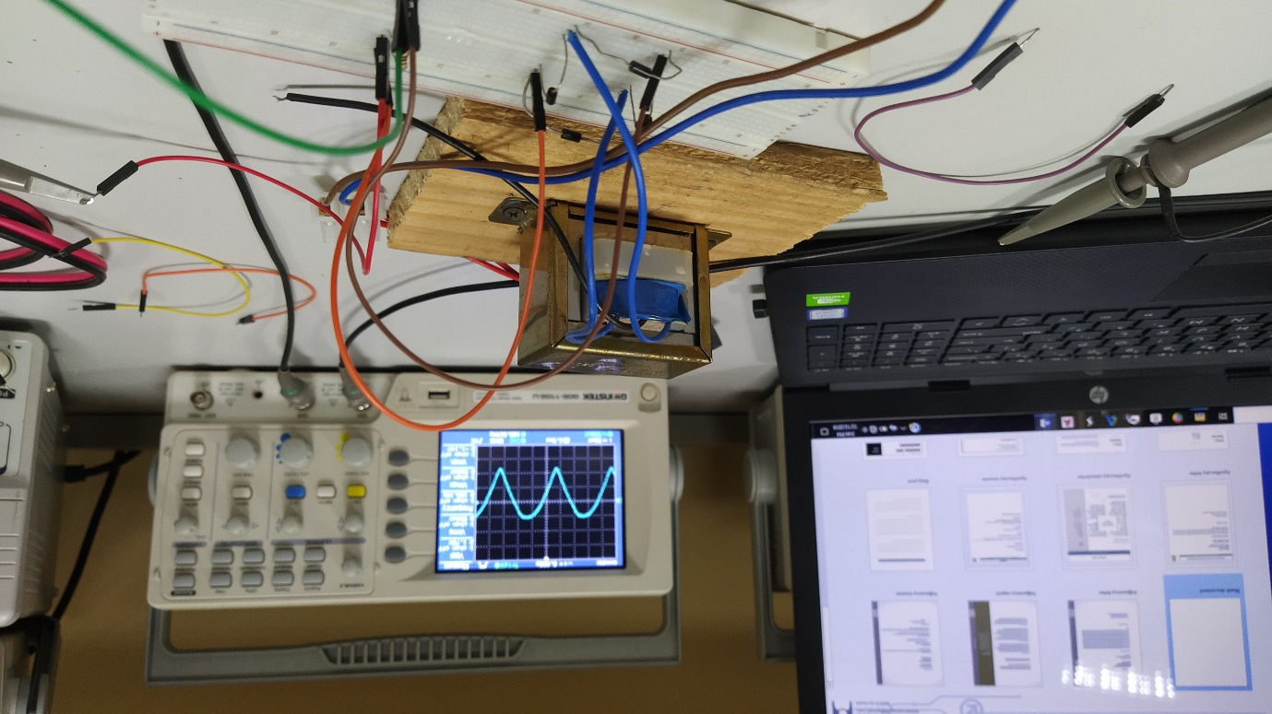By adding a 47uF which is higher than 22uF, it is shown the wave has become smoother due to higher capacity of the capacitor.

Figure 38 Circuit of the Full wave rectifier

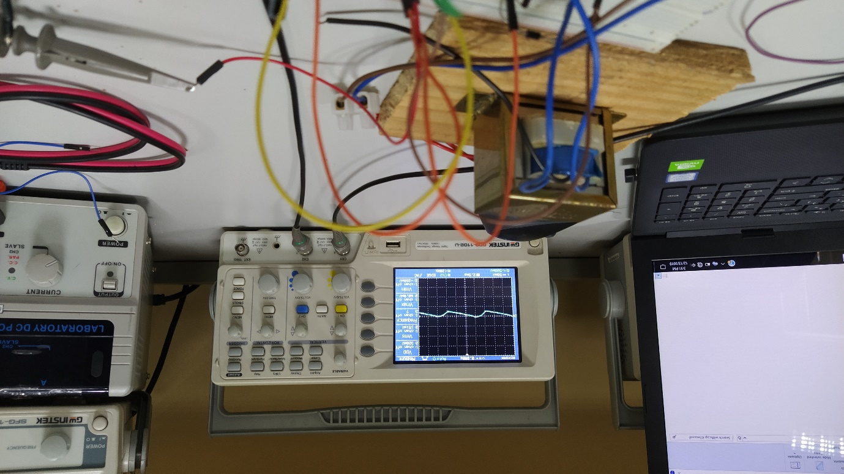

Figure 39 Full wave rectification with capacitor

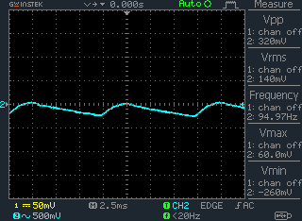

Figure 40 Full wave rectification with data

# Task 3

## Objective

The objective on this task is to identify how operational amplifier works both inverting and non-inverting methods.

## Equipment

Resistors with 10kΩ and 1kΩ, UA471 Operational amplifier, jumper wires, breadboard, function generator, DC power supplier, oscilloscope

## Methodology

#### Inverting Operation amplifier

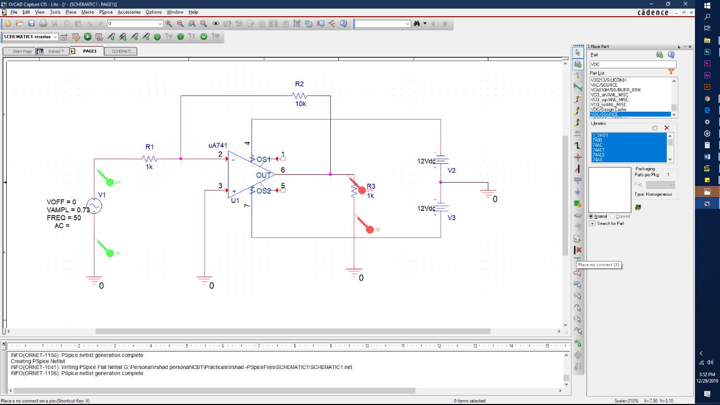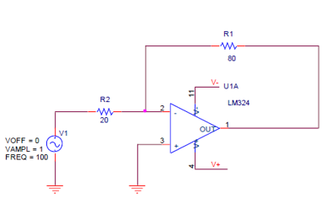

Figure 41 Orcad design of the inverting op-amp

Figure 42 Diagram of the inverting op-amp

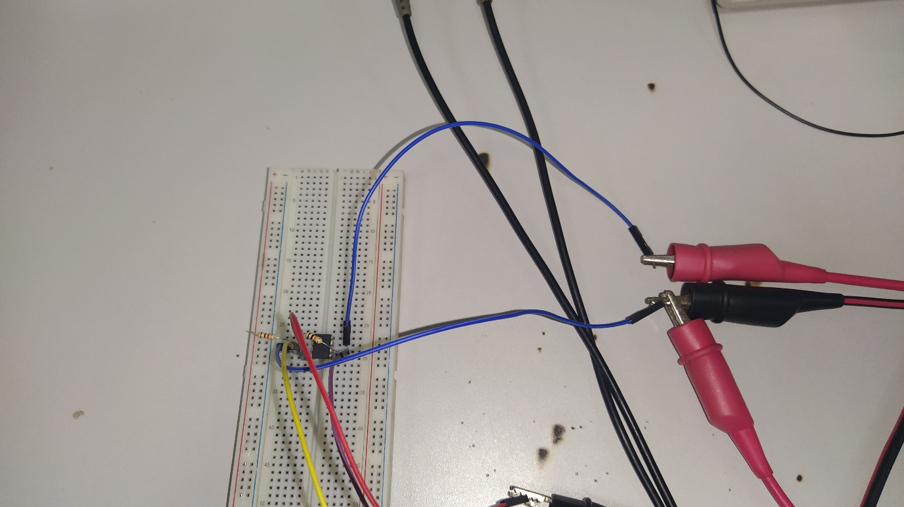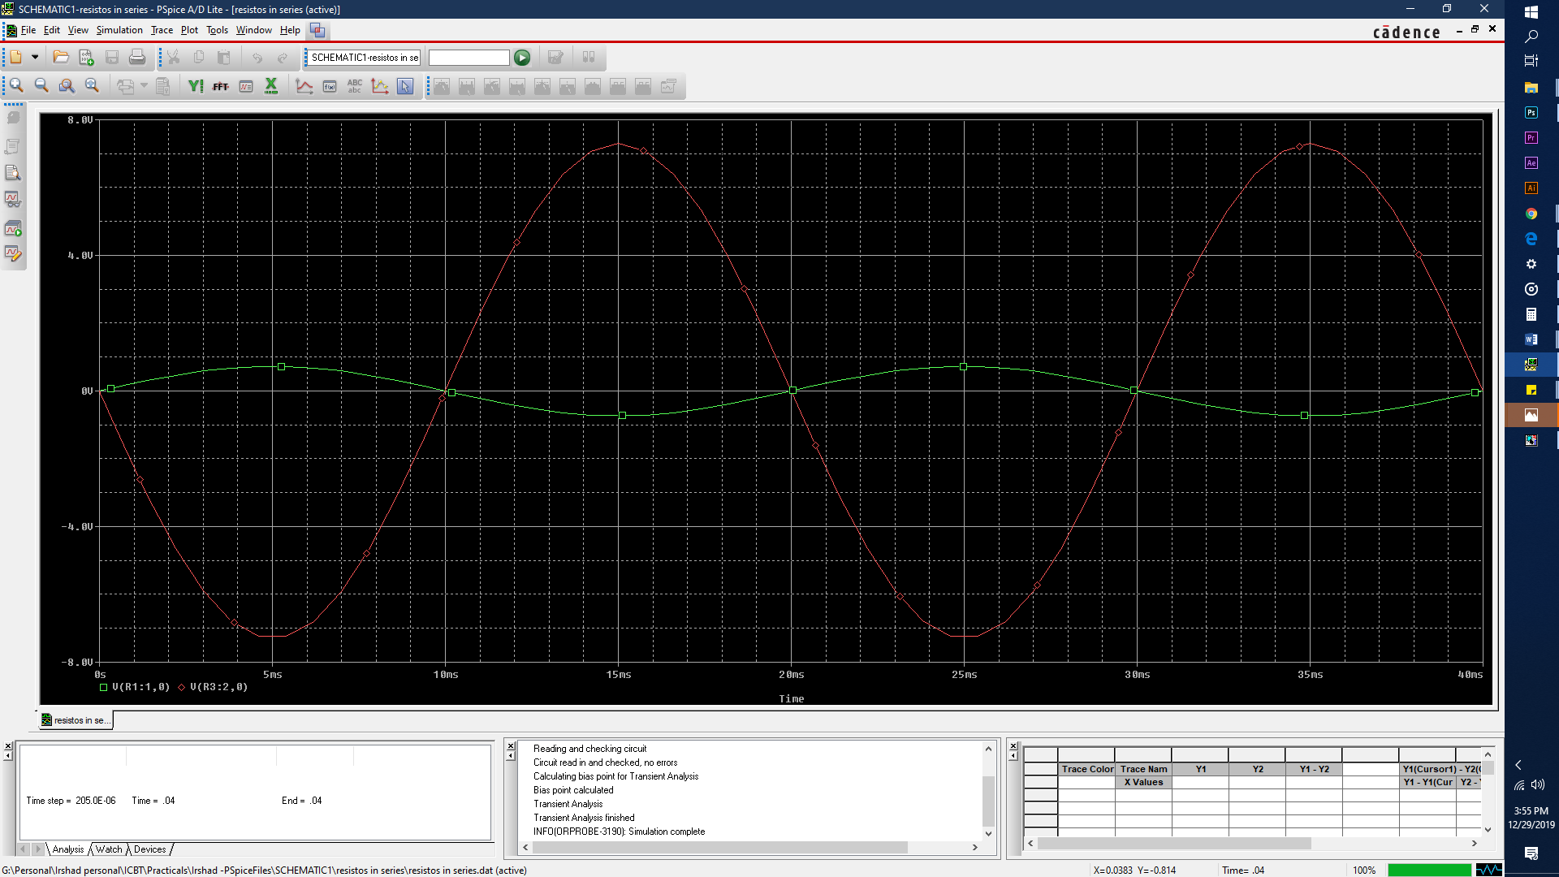

Figure 43 Circuit design of Inverting op-amp

Figure 44 Output wave form of inverting op-amp

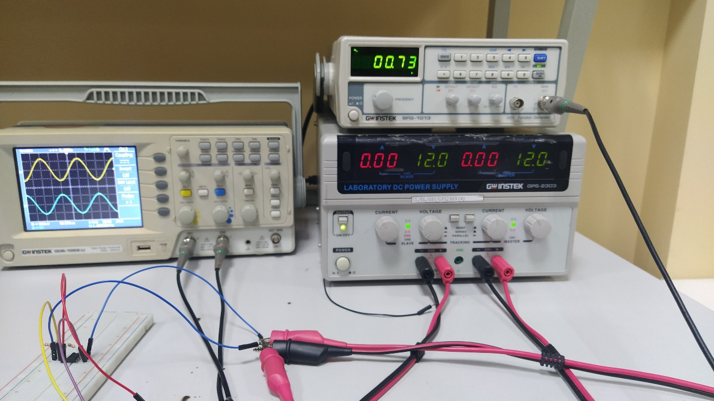

Figure 45 inverting op amp data

#### Non-inverting operation amplifier

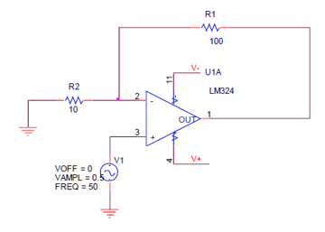

Figure 46 diagram of non inverting op-amp

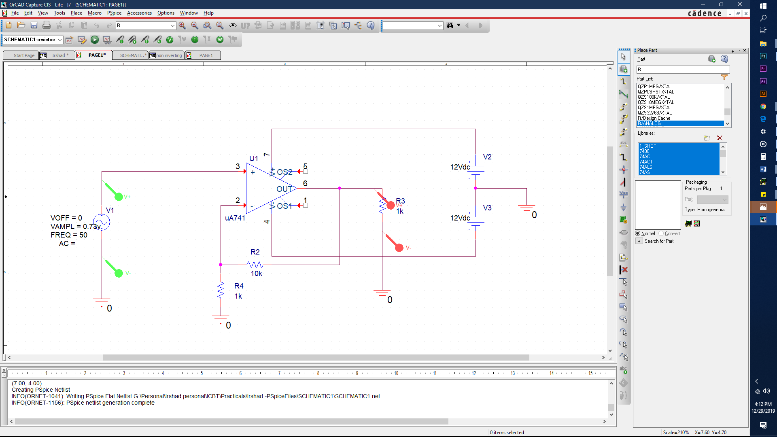

Figure 47 Orcad design of non inverting op-amp

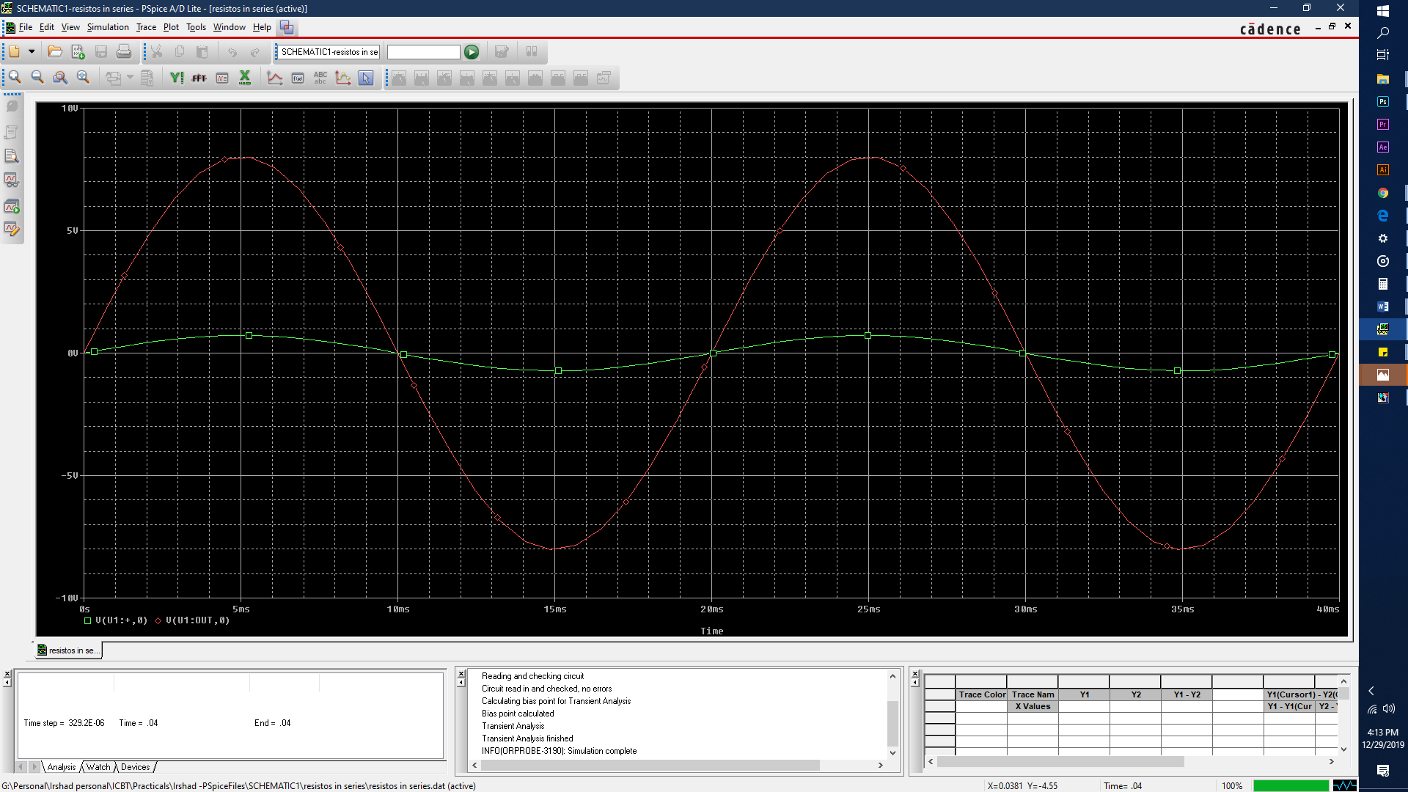

Figure 48 output wave form of non inverting op-amp

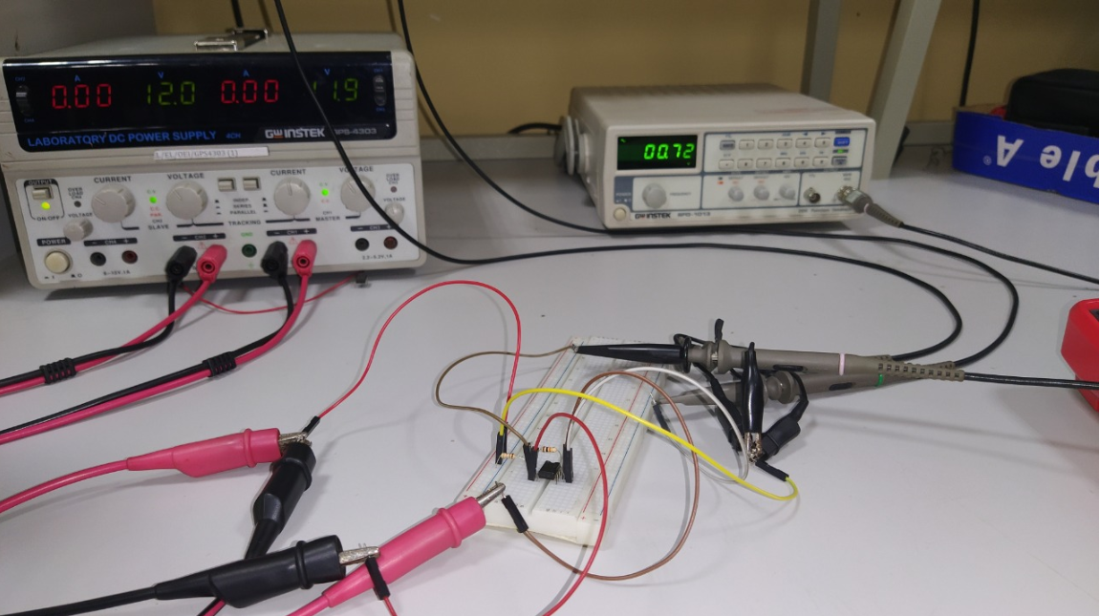

Figure 49 Circuit of the non onverting op-amp

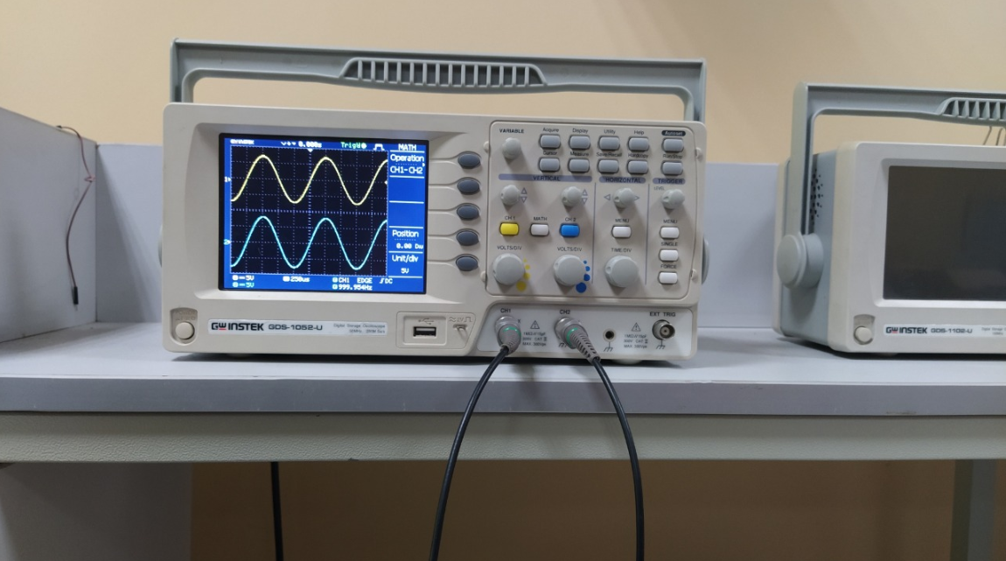

Figure 50 Data of the non inverting op-amp

# Task 4

## Objective

By this experiment it should show how to use a transistor as an amplifier.

## Equipment

Transistor , 4 variable resistors, DC Power supply, Bread board, jumper wires,

### Methadology

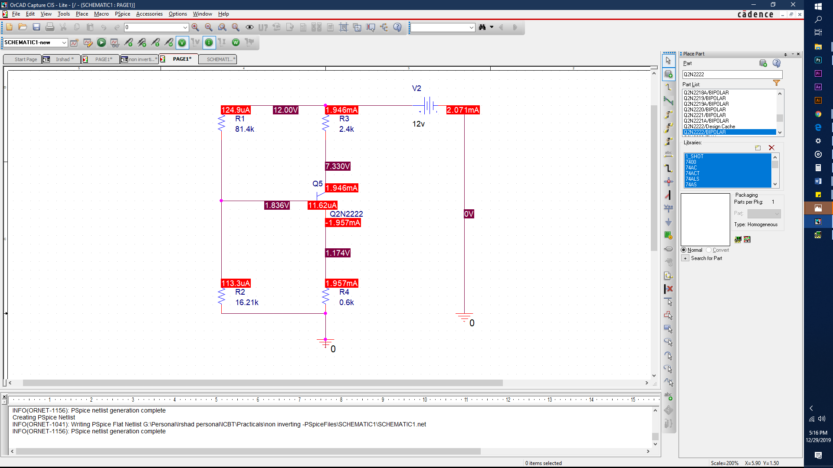

Figure 51 Orcad design

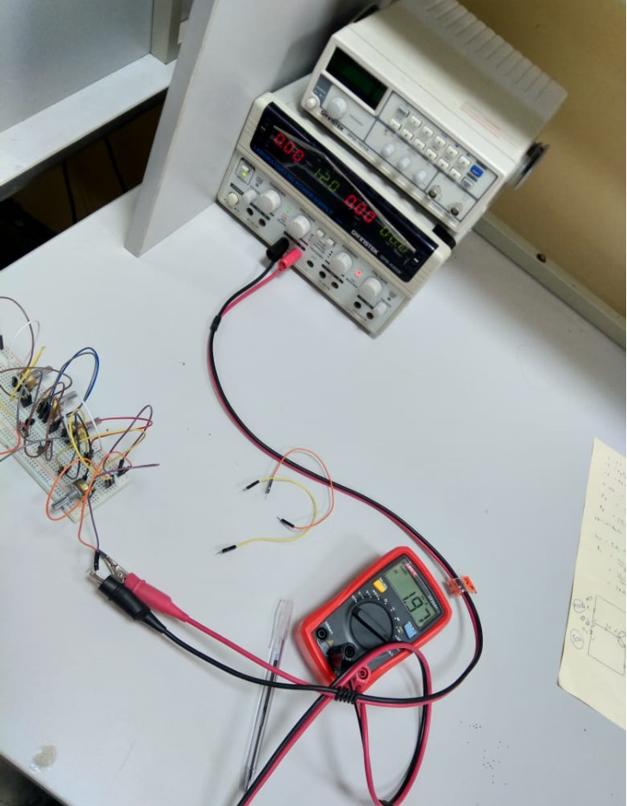

Figure 52 IC current value

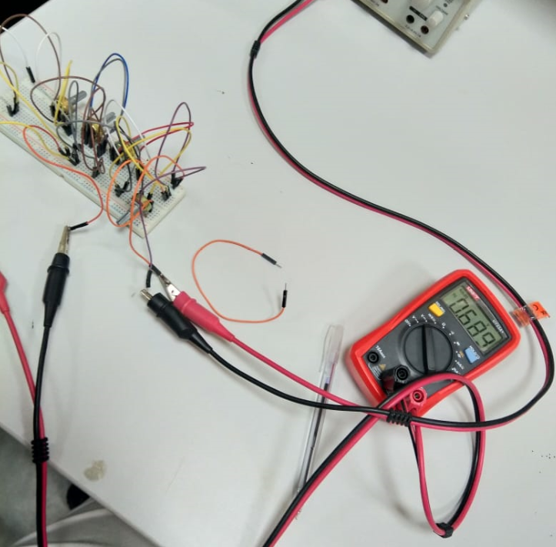

Figure 53 Vbe value